**TeleHealth – Virtual Multidisciplinary Team Meetings**

Sam Yan

Student ID: 886958

E-mail: yanjia@kean.edu

eHealth department of University of Melbourne, Australia

INTRODUCTION

This projects ask for a solution on an enterprise level video conferencing software, under the circumstance of cancer patients’ healthcare services. For the purpose of this scenario, several entrepreneur level video conferencing software solutions are compared and Zoom Video Webinar is the proposed suggested solution in this case, after analyzing of various aspects. Main factors considered includes functionality, cost-effective issues and portability (cross-plat form) issues.

1. CHOSEN SOLUTION:
   1. Preferred solution

There are several considerations about choosing Zoom Webinar to be the preferred solution. Firstly, Zoom Webinar seems to be more cost effective compared to Cisco WebEx, which could be the most competitive solution to the proposed one for its various functionalities. For example, as for the same meeting requiring around 100 participants, Zoom needs around $21 while Cisco WebEx requires $69. Therefore, in a problem scenario which stresses “medium level of budget”, Zoom tends to stand out based on this comparison. Other types of plat-form specific video conferencing software such as Microsoft Skype for business, also provide rich functions and cheaper prices, but the software would then be limited to only certain operating systems.[1] Thus, those video conferencing software that are able to run only on certain flat-forms are less satisfied in portability issues compared to the two solutions proposed above. ("plans and pricing - Zoom," n.d.) ("Cisco WebEx Meetings Pricing. Choose a plan that’s right for you..," n.d.). Other potential alternative solutions are either too large in size (which means spending too much extra costs on buying licenses, e.g.Adobe Connect, AT & T connect), or suffers in functionality (e.g.Adobe Connect only allows certain types of files to be uploaded, also such as AnyMeeting which does support whiteboard demonstration).

* 1. Reasons to choose

First of all, using Zoom Webinar to create and schedule a meeting is very easy. “100 other healthcare workers are able to be invited by oncologists and nurses to the meeting”, according to the introduction, by emails about the meeting information to them. (See assumption 2) The emails can be further added into the corresponding calendar systems (for example, as for Gmail, those information can be added into the audiences’ Google calendar). As a third way, the attendees can be invited through URL. Scheduling functions are provided by Zoom Webinar. (“How Do I Invite Others To Join a Meeting? – Zoom Help Center,” n.d.) To attend the meeting, the audiences of different health management roles just need to click the join button on the panel of installed Webinar. The operating system able to run this application includes Windows, IOS and Linux. Furthermore, attendees of the meeting can simply open a browser and join the meeting using the inviting URL at any location where internet is available, without pre-installation of the application, which provides a portable solution among different end user platforms and offers healthcare community with certain extends of mobility. (“How Do I Invite Others To Join a Meeting? – Zoom Help Center,” n.d.)

Secondly, Zoom Webinar supports many user interacting functions required by this scenario. Both high quality of VoIP and toll-based options are available internationally. (“Audio Plan - Zoom,” n.d.) Remote control, share screen functions and “live white panels” are provided, allowing oncologists and nurses to share information, certain files (e.g.radiological data about the patient) and to demonstrate knowledge in a more interactive manner. (“Request or Give Remote Control – Zoom Help Center,” n.d.). Host can hand over the presentation to another attendee by enabling the person as a “co-host”.

Last but not least, the videos can be recorded and stored into the Zoom cloud for further education purposes or reviewing purposes. (“Upload Local Recording to the Cloud – Zoom Help Center,” n.d.)

1. 3 THINGS TO DISCUSS：
   1. LICENSING

For this particular scenario, licensing policies for Cisco Webex, Zoom Webinar and Adobe Connect are compared (See assumption 1).



*Figure 1: Part of the licensing plan by WebEx, from URL:* <https://www.webex.com/wx11/index.html>

As for Cisco WebEx licenses, for each license holder, the person enjoys a rich amount of functions from meeting inviting and scheduling, interactions during the meeting, VoIP or toll-based voice transmission needs, file sharing and whiteboard, providing each user with rich functions and the preferred audience scale as they require. However, user requirements of the functions are changing, especially in the hospital environment. Furthermore, an oncologist may meet different scale of groups at different times among different months. If this happens, the licenses have to be renewed, which might not be convenient and suggested that this solution is not flexible, compared to the chosen solution Zoom Webinar.

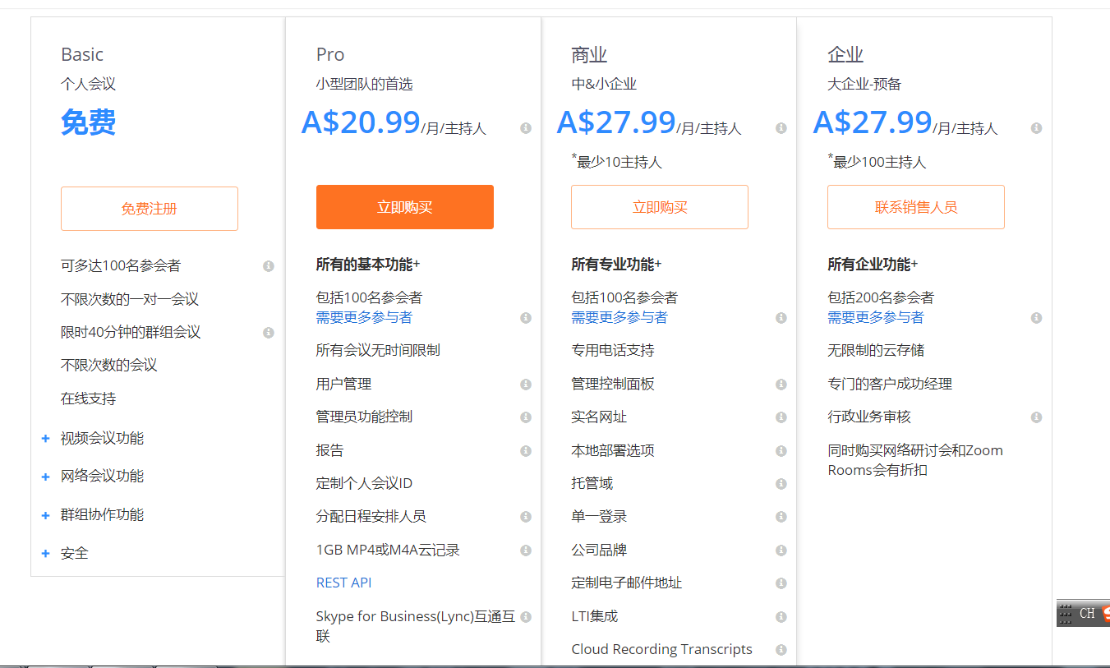

*Figure 2: Part of the licensing plan for Zoom Webinar, from URL:* [*https://zoom.us/pricing*](https://zoom.us/pricing)

For Zoom Webinar, they provide basic webinar services at much lower prices compared to other types of named licenses provided by other companies. Secondly, users can choose to purchase those functions they need only, according to the group type he or she meets, which provides users cheaper prices and flexibilities. However, there are compromises that are worth noticing. Their $27.99 option are for concurrent license, which might cause some waste in the licenses if number of oncologists are not that much. Secondly, lower prices offers less functions. User experiences in this case might suffer as well, for example, users might need to purchase VoIP functions when they need.

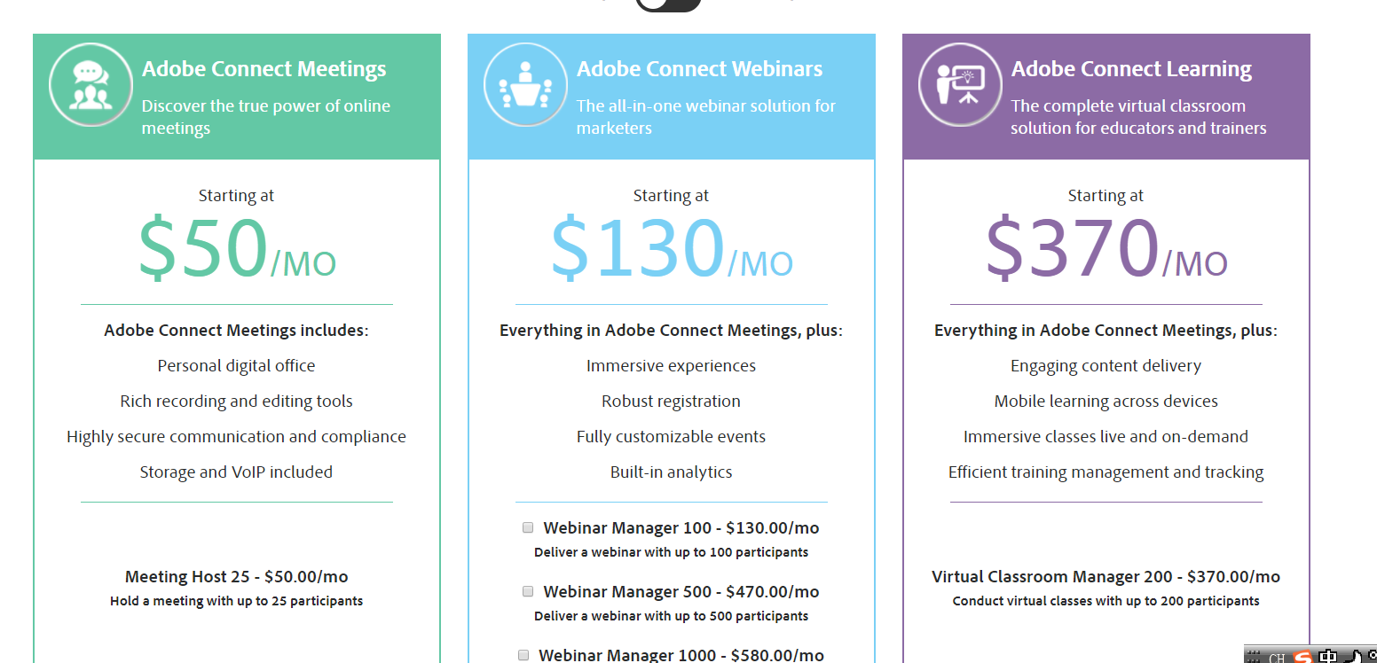

*Figure 3: Part of Adobe Connect licensing plan, from* [*URL:http://buyconnect.adobe.com/store/adbecnn/Content/pbpage.LandingPage*](URL:http://buyconnect.adobe.com/store/adbecnn/Content/pbpage.LandingPage)

As for Adobe Connect licenses, they are designed particularly for large-scale enterprise video conferences. Therefore, each license provides user with very rich functionalities, even the $50 license provides storage of the video and VoIP services. At the same time, they are easy to scale up. However, those type of licenses does not fit the problem scale (see assumption 2). Secondly, those kind of license obviously cost more compared to the proposed solution.

* 1. END USER DEVICES & CONNECTIVITY

For end user devices allowed and special connectivity strategies used for video conferences, the conferencing software, Cisco WebEx, Zoom Webinar and Business for Skype are compared.

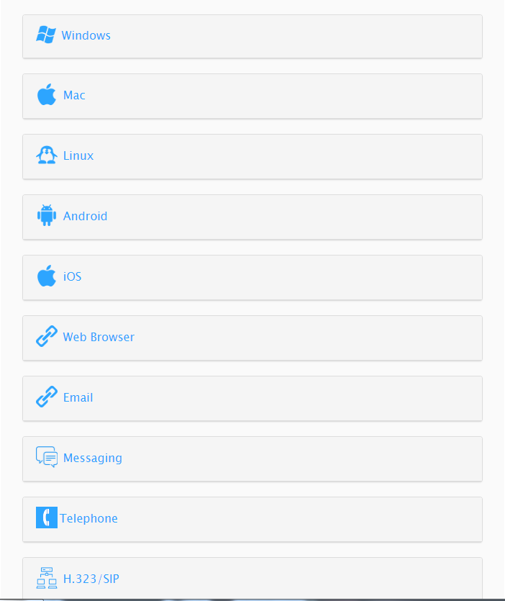

*Figure 4: Figure of supported devices that can join the meeting in Zoom, from* [*URL:https://support.zoom.us/hc/en-us/articles/201362193-How-Do-I-Join-A-Meeting-*](URL:https://support.zoom.us/hc/en-us/articles/201362193-How-Do-I-Join-A-Meeting-)

Zoom Webinar supports a variety of devices as shown above, including 3 major desktop operating systems (Windows, Linux and Mac) and the 2 major smart-device operating systems (Android, IOS). Secondly, for the network connection, Zoom Webinar allows SIP (Session Initiation Protocol) (Nalawade, Nema, & Yalampati, 2017), which is specially designed for multi-media network, thus reducing the load of general network and leaving more space for quickly transferring of other kinds of data.

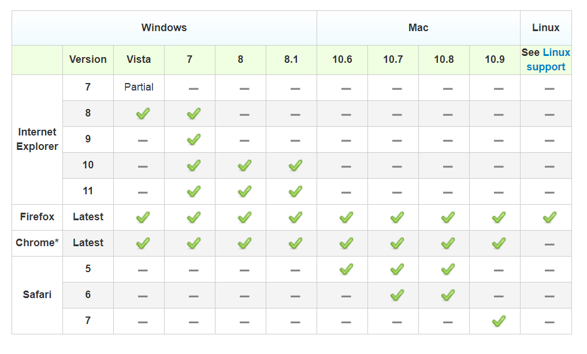

*Figure 5: Supported OS of Cisco WebEx, from URL:* [*https://www.webex.co.uk/support/support-system-requirements.html*](https://www.webex.co.uk/support/support-system-requirements.html)

Cisco WebEx supports a wider range of devices compared to Zoom Webinar. As for operating systems, apart from Windows, Mac and Linux, it further supports Blackberry, leaving possibilities for using embedded systems to join into the webinar. It supports all major current mobile systems as claimed by itself. Although Cisco seems to win out in the aspect of user devices and connectivity, choosing a solution for such a scenario needs to consider other issues as well.

Business for Skype supports Windows and Mac systems only (“Join a Skype for Business meeting - Office Support,” n.d.), which is a major limitation of this kind of webinar applications. (See assumption 3) However, Business for Skype also comes up with its own “shiny point” in connectivity because cookies are enabled in this software, leading to a shorter user access time and RTT (Round-Trip-Time). (James F. Kurose, 2012). Secondly, this solution less a further cheaper price due to less device-supports and easier network infrastructure. (“Pricing for Skype for Business and Teams: The 2017 Update - The Skype for Business Insider,” n.d.)

* 1. USER EXPERIENCE

In order to use Zoom Webinar, a user should be able to have a device which connects to Internet. Previously to the meeting, the user can receive invitation to the meeting by emails after starting the device, and if his or her mail service provides calendar services, the date, time and topic of the meeting would be stored into the calendar. When it is time for the meeting, if Zoom is previously installed, the link sent to the user from email services will take him or her to the meeting directly. Otherwise, he or she can join the meeting by inputting the URL of the meeting into a web browser. The URL will then automatically lead the user to the installation processes of the Zoom Webinar software. During the meeting, the user can interact with the host through whiteboard demonstration. He or she can also send invitation to the host, applying to be a co-host if necessary. After the meeting, the user is able to view the video if the hosts already uploaded it to the cloud to further review and investigate into details.

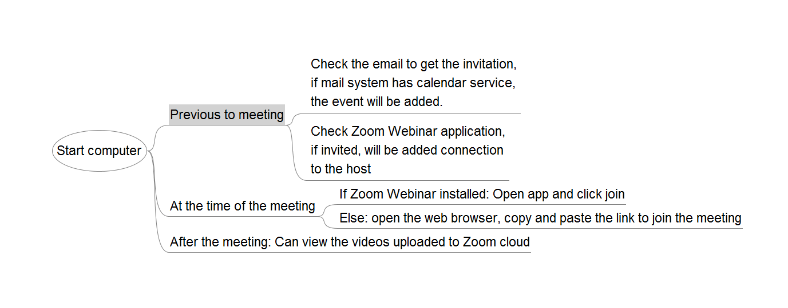

*Figure 6: The flow of a participant using Zoom Webinar, created according to the analysis of Zoom Webinar from various Bibliographies.*

(Word count: 1299, by excluding the INTRODUCTION, captions of the figures, and citation or explanation notations)

ASSUMPTIONS

1. For each oncologist in the hospital, they treat different cancer patients, and thus have needs to meet different number of nurses, local general practitioners, local nurses and local pharmacy person and so on around different patients. In this case, named licensing would be a much better choice compared to concurrent licensing, because the requirements of different oncologists at the same time might vary a lot from one another. And named licensing which provides licenses under the name of each oncologist or nurse would satisfy the particular needs of their particular roles and jobs.
2. The healthcare community of a patient should be less than 50 people. (Even considering all possibilities of the health providers of a patient, it would be ridiculous to have more than 50 people servicing the same person of the exact same disease). Under this assumption, a group level webinar (usually allows 100 audiences and 1 – 10 audiences, e.g.Zoom Webinar, Cisco WebEx, of the 2 option) should be of enough scale.
3. One trend of studying and treating cancer those days is to refer to patients’ genomic data. However, data related to genomic information (e.g.BAM/SAMFiles) are usually in Linux forms for higher throughput sequencing purposes. Sometimes, it would be even worse that those data cannot be run on platforms other than Linux and data used on other platforms. (Cmero et al., 2017) Thus, in the case of an oncologists’ related network, allowing sharing and transmitting data using Linux based platforms is important.

BIBLIOGRAPHY:

Grozev, B., Politis, G., Ivov, E., & Noel, T. (2018). Considerations for deploying a geographically distributed video conferencing system. In 2018 IEEE 8th Annual Computing and Communication Workshop and Conference (CCWC) (pp. 357–361). <https://doi.org/10.1109/CCWC.2018.8301726>

Reason to list as top 3: This paper introduced common issues that we need to consider when deploying an infrastructure for distributed video calling systems, which is worth referring to for both this project and the major project.

Kurose, J. F., & Ross, K. W. (2013). Computer networking: a top-down approach (6th ed). Boston: Pearson.

Reason to list as top 3: The general books about computer network introduces network from physical layer up to application layer. However, this book takes an up-side-down approach, leading us from knowing the application layer which is the most close layer to our daily life to deep physical layers, providing us a totally new perspective of viewing the network.

Nalawade, N. R., Nema, S., & Yalampati, S. (2017). Efficient IP-based voice video communication through session initiation protocol (SIP). In 2017 International Conference on Intelligent Computing and Control (I2C2) (pp. 1–5). https://doi.org/10.1109/I2C2.2017.8321862

Reason to list as top 3: This paper introduced us some knowledge about SIP protocol designed for transmitting multimedia data, which introduced us rich knowledge about SIP. Plus, it proposed an optimized solution for SIP infrastructure, which is the reason making it worth reading through.

Adobe Connect Store. (n.d.). Retrieved April 12, 2018, from <http://buyconnect.adobe.com/store/adbecnn/Content/pbpage.LandingPage>

chris.williams. (2017, September 20). Pricing for Skype for Business and Teams: The 2017 Update. Retrieved April 12, 2018, from <http://skype4businessinsider.com/skype-for-business/pricing-skype-business-teams-2017-update/>

Cisco WebEx app. (n.d.). Retrieved April 12, 2018, from <https://www.webex.com.au/products/web-conferencing/mobile.html#cisco-webex>

Cisco WebEx Meetings Pricing. Choose a plan that’s right for you.. (n.d.). Retrieved April 9, 2018, from <https://www.webex.com/wx11/index.html>

Cmero, M., Ong, C. S., Yuan, K., Schröder, J., Mo, K., Corcoran, N. M., … Macintyre, G. (2017). SVclone: inferring structural variant cancer cell fraction. <https://doi.org/10.1101/172486>

Comparison of web conferencing software. (2018, March 19). In Wikipedia. Retrieved from <https://en.wikipedia.org/w/index.php?title=Comparison_of_web_conferencing_software&oldid=831208405>

Enabling and Adding a Co-Host – Zoom Help Center. (n.d.). Retrieved April 12, 2018, from <https://support.zoom.us/hc/en-us/articles/206330935-Enabling-and-Adding-a-Co-Host>

How Do I Invite Others To Join a Meeting? (n.d.). Retrieved April 12, 2018, from <http://support.zoom.us/hc/en-us/articles/201362183-How-Do-I-Invite-Others-To-Join-a-Meeting->

How Do I Join A Meeting? (n.d.). Retrieved April 12, 2018, from <http://support.zoom.us/hc/en-us/articles/201362193-How-Do-I-Join-A-Meeting->

Hsueh, C. C., & Luo, Y. C. (2013). A taxonomy of utility model patents application strategy. In 2013 Proceedings of PICMET ’13: Technology Management in the IT-Driven Services (PICMET) (pp. 946–952).

Join a Skype for Business meeting. (n.d.). Retrieved April 12, 2018, from <https://support.office.com/en-us/article/join-a-skype-for-business-meeting-3862be6d-758a-4064-a016-67c0febf3cd5>

Request or Give Remote Control. (n.d.). Retrieved April 12, 2018, from <http://support.zoom.us/hc/en-us/articles/201362673-Request-or-Give-Remote-Control>

Sathiyaseelan, A. M., Joseph, V., & Srinivasaraghavan, A. (2017). A proposed system for preventing session hijacking with modified one-time cookies. In 2017 International Conference on Big Data Analytics and Computational Intelligence (ICBDAC) (pp. 451–454). <https://doi.org/10.1109/ICBDACI.2017.8070882>

Video Conferencing, Web Conferencing, Webinars, Screen Sharing. (n.d.). Retrieved April 12, 2018, from <https://www.zoom.us/>

Zoom Webinar - Zoom. (n.d.). Retrieved April 12, 2018, from https://zoom.us/webinar

1. This issue will be further explored in the “end-user devices and connectivity” part.